Please define the following words on a separate piece of paper. Most can be found in your reading on pages 318 – 327.
- Republic
- Senate
- Citizens
- Carthage
- Empire
- Facilitated
- Aqueducts
- Romulus and Remus
- Pax Romana
- Plebian
- Patrician
- Togo
- Forum
- Gladiator
- Colosseum
- Pantheon
- Latin
- Baths
- Circus Maximum
- Chariots
- Legions
- Mt. Vesuvius
- Barbarian

All Roads Lead to Rome
Answer the following questions:
- The Romans were first ruled by Latin, then Etruscan kings. What did the Romans learn from these Etruscans?

- When the nobles forced out the last king, what kind of government did they establish?

- By 100 B.C., Romans ruled much of the world around the Mediterranean Sea. How were they able to do this?

- Julius Caesar became a powerful military leader. Why did a group of senators in Rome kill him?

- Who was Octavius and how did he come to be Rome’s first emperor?

- Many Roman structures, built 2000 years ago, are still standing today? How is that possible?

- Rome’s literary achievements and legal system are still admired today. What is one country that has based its entire legal system almost entirely on Rome’s legal system? How are they alike?

- What religion was established during the time of the Roman Empire?

- Why were some of Rome’s leaders concerned about the rapid growth of Christianity? How did it become accepted by Rome?

- Why did Constantine move the capital of Rome to Constantinople?

- Why did the barbarian invasions of Rome succeed?

- What were some causes of the decline of the Roman Empire?

13. What continents did the Roman Empire occupy?

14. What was the Pax Romana Era?

15. What region did Christianity begin?

16. Who were patricians and plebeians?

17. What were the responsibilities of the two consuls?

18. Who elected officials to government offices?

19. What were judges called and what could happen after their retirement?
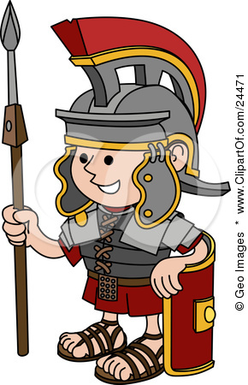
20. What part of the government ended up controlling all of Rome?

21. What were tribunes?

